Jones Co. Youth rodeo event  hosted by trail of faith farms  When  June 27, 2015  10am  Where  Bright Star Farm  208 Pleasant Hill Rd. Trenton, NC 28585  Events ·Stick Horse Race (ages2-13)·Goat Ribbon Pullin’(ages 4-13)·Youth Calf Scramble(ages 4-12) · Potato Sack Race(all ages)·Mutton Bustin’(ages 4-7) ·Boot Scramble(ages 5-9)·  web address  https://m.facebook.com/trailoffaithfarms or  www.trailoffaithfarms.weebly.com  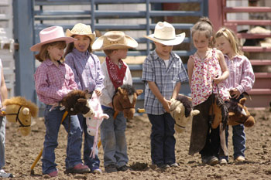 |  |  | Adult Event·Corn hole tournement·winning team will win prize $  Advance registration for the youth events  $5 entry fee with registration, due June 12. Mail to:  Trail of Faith Farms  190 Heritage Trl. Trenton, NC 28585  At the gate  $5 entrance fee  Farm Fun  Food and soft drinks· Face painting· Rodeo Fun and Games for the whole family·  